Ideation Phase
Define the Problem Statements

Date | 18 June 2026
Student Name | Ch.Sai Shruthi
Project Name | ShopEz
Maximum Marks | 2 Marks

Customer Problem Statement Template:
Create a problem statement to understand the needs, expectations, and challenges faced by online shoppers. The Customer Problem Statement helps the ShopEZ development team focus on building a secure, user-friendly, and efficient online shopping platform.
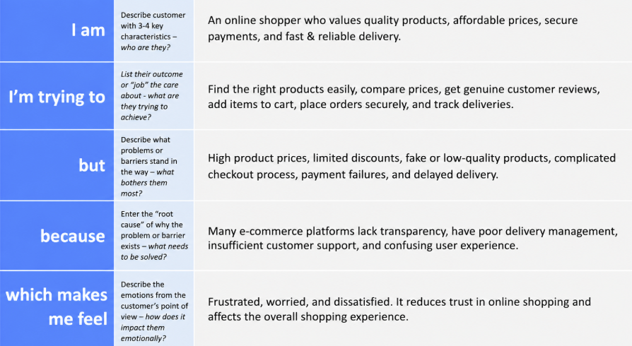
ShopEz-Online Shopping Platform

Problem Statement (PS) | I am (Customer) | I’m trying to | But | Because | Which makes me feel
PS-1 | An online shopper | Find and purchase quality products online | I face difficulty finding trustworthy products and good deals | Product information and reviews are sometimes unclear or insufficient | Confused and uncertain while making purchase decisions
PS-2 | An online shopper | Complete purchases quickly and securely | I experience complicated checkout processes and delivery delays | Some platforms have poor user experience and inefficient order management | Frustrated and dissatisfied with online shopping

